Name: Shreyans Tatiya
Batch: C5_3 Roll No.: 16010123325

Experiment / assignment / tutorial No. 2

Grade: AA / AB / BB / BC / CC / CD /DD

Signature of the Staff In-charge with date

TITLE: a. Write a program to accept 3 numbers from the user and find the largest of the
3 numbers using
If - else if-else
Ternary operator
b. Write a C program to find the grade of a student using switch case statements.

AIM: a. Write a program to accept 3 numbers from the user and find the largest of the 3 numbers using
If - else if-else
Ternary operator
b. Write a C program to find the grade of a student using switch case statements.
The below table shows the grading system.

Score in subject | Grade
>=90 | A
80-89 | B
70-79 | C
60-69 | D
50-59 | E
<50 | F

______________________________________________________________________
Expected OUTCOME of Experiment:
Apply basic concepts of C programming for problem solving.(CO1 and CO2).

_____________________________________________________________________
Books/ Journals/ Websites referred:

- Programming in C, second edition, Pradeep Dey and Manas Ghosh, Oxford University Press.
- Programming in ANSI C, fifth edition, E Balagurusamy, Tata McGraw Hill.
- Introduction to programming and problem solving , G. Michael Schneider ,Wiley India edition.
- http://cse.iitkgp.ac.in/~rkumar/pds-vlab/

_____________________________________________________________________
Problem Definition:

- Ask user to input three numbers. Compare three numbers to find the largest of them using
- Nested if else statement
- Using ternary operator
- Write a C program to find the grade of a student using switch case statements.
The below table shows the grading system.

Score in subject | Grade
>=90 | A
80-89 | B
70-79 | C
60-69 | D
50-59 | E
<50 | F

Algorithm:

Implementation Details:
1a)
Using Nested if else if

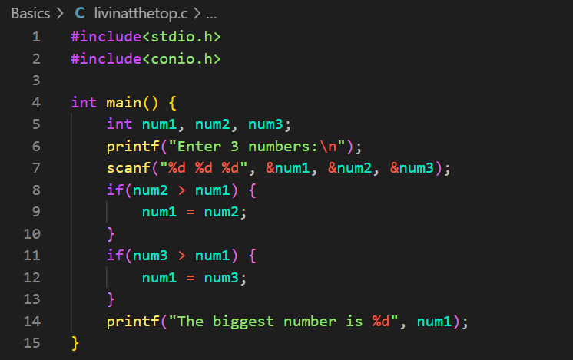

Using Ternary Operator
1b)
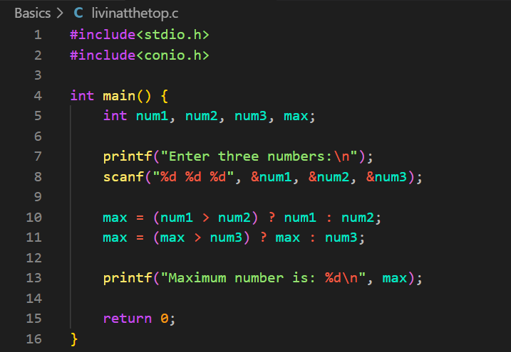

2)
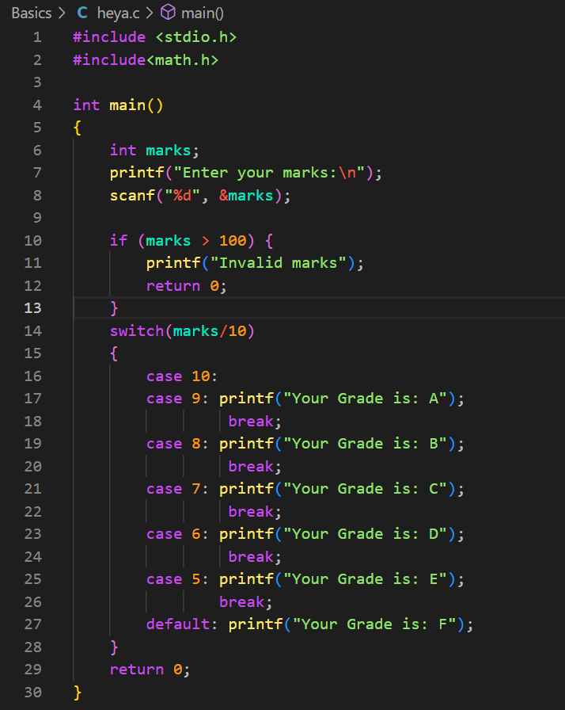

Output(s):
1)
Using nested if & else statements:
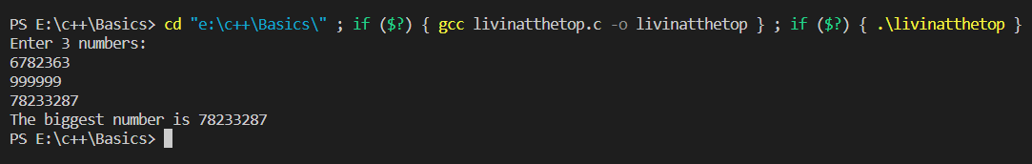
Using Ternary Operators:
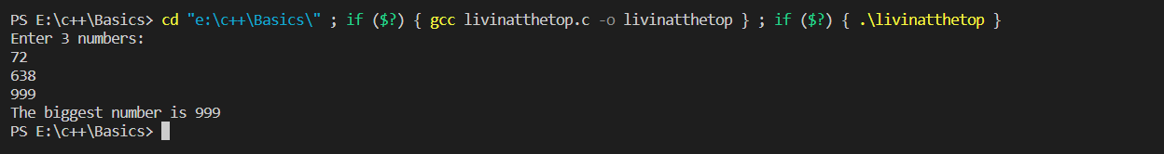
2)
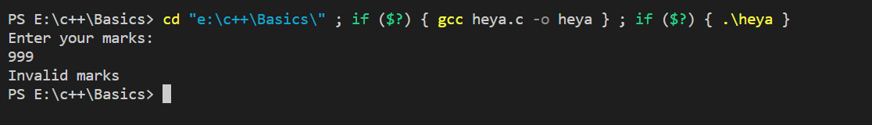
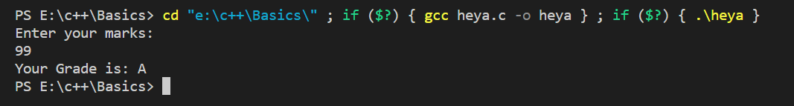
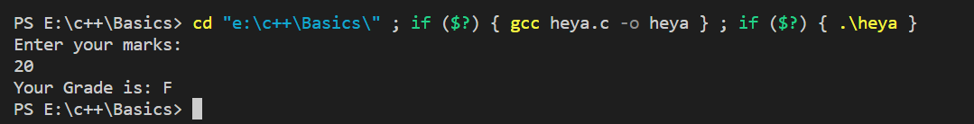

Conclusion:
Successfully executed Exp 2.
Learnt to use conditional statements i.e. if-else and ternary operators. Also learnt to write algorithms for programs.

Post Lab Descriptive Questions
- Virtual lab for switch statement
https://cse02-iiith.vlabs.ac.in/exp/basic-control-flow/simulation.html

- Virtual lab for if statement
https://cse02-iiith.vlabs.ac.in/exp/basic-control-flow/simulation.html

Date: _____________ Signature of faculty in-charge

